**OUTREACH SCHOOLS EXAMINATION BOARD**

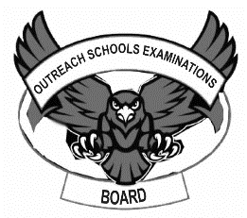**MID TERM III EXAMINATION 2023**

**TOP CLASS: (5 – 6 YEARS)**

**LEARNING AREA 1: SOCIAL DEVELOPMENT**

**My name is: ……………………………………………………………….**

**My School is: …………………………………….………………………..**

**I am in: ………………………………..…………………………….…………………..**

1. What is your name?

______________________________________

1. **Name the pictures.**

_____________________

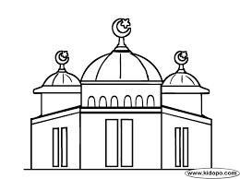

_______________________

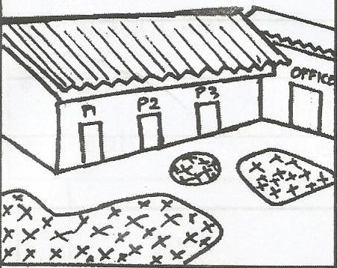

_______________________

1. **Read and draw.**

father

mother

uncle

baby

1. **Fill in the missing letters.**

sh__p mark___t h__spital

1. **Name the means of transport**

**bus lorry bicycle boat**

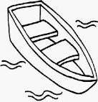

________________________

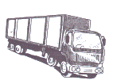

_________________________

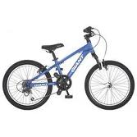

_________________________

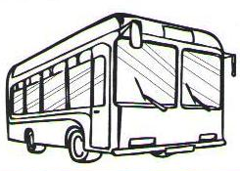

_________________________

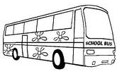

1. **Shade the traffic lights.**

**red**

**orange**

**green**

**END**